Home page displays TOP 3 rating recipe.

localhost/recipe.dev or localhost/recipe.dev/home or localhost/recipe.dev/home/index

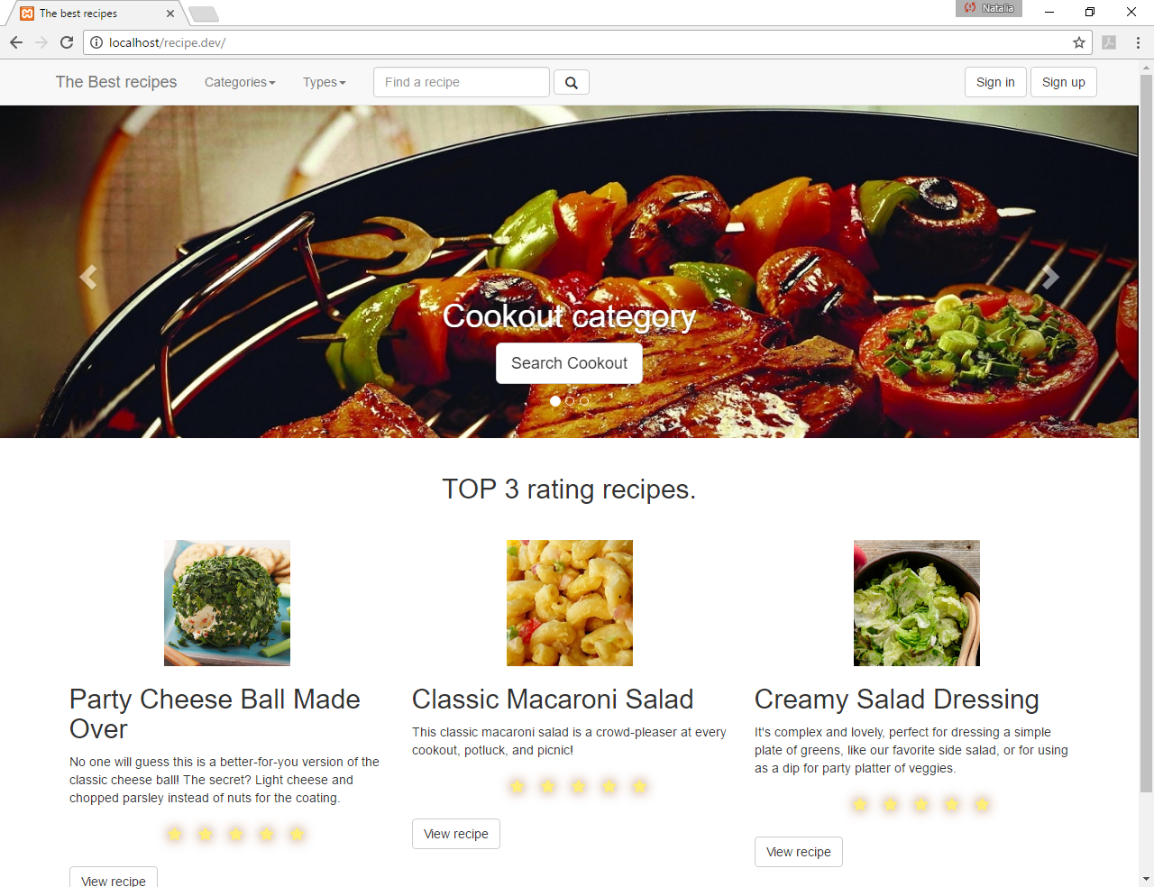

Click The Best Recipe to come back to Home page.

Click Category to search by category

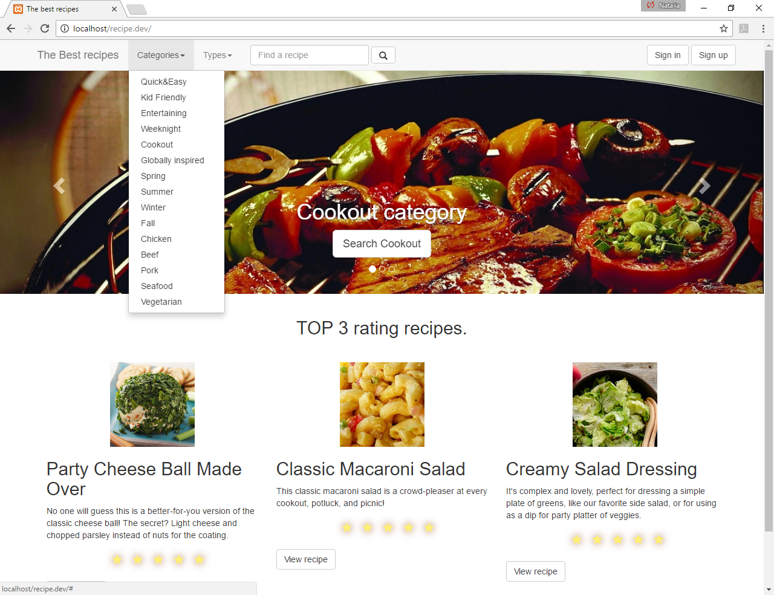

Result searching by category “Entertaining”

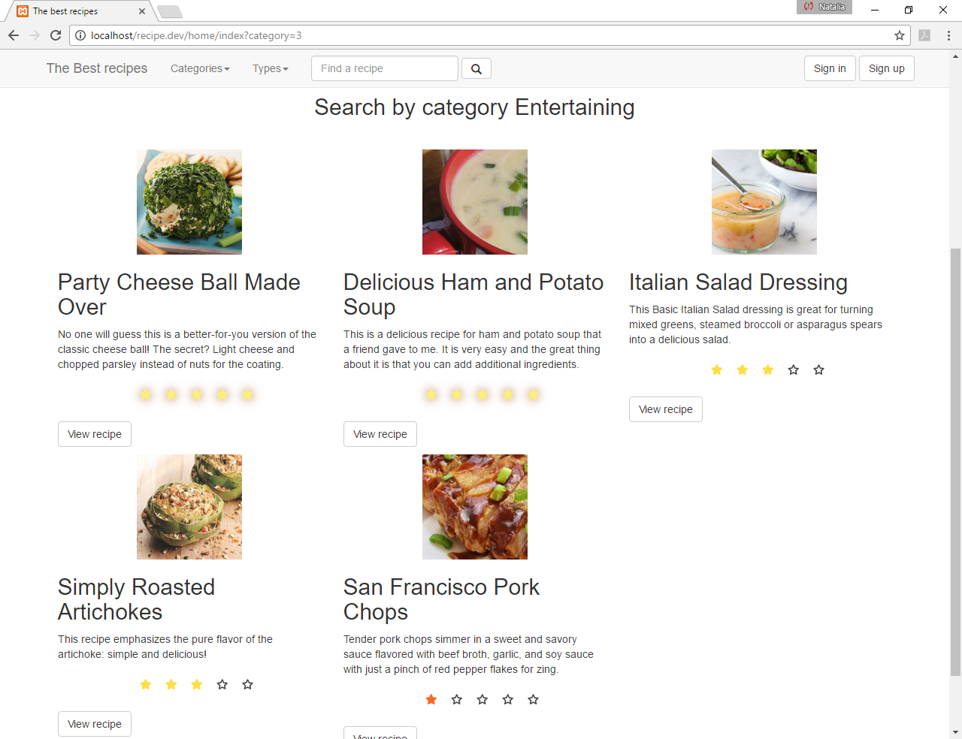

Click Type to search by Type

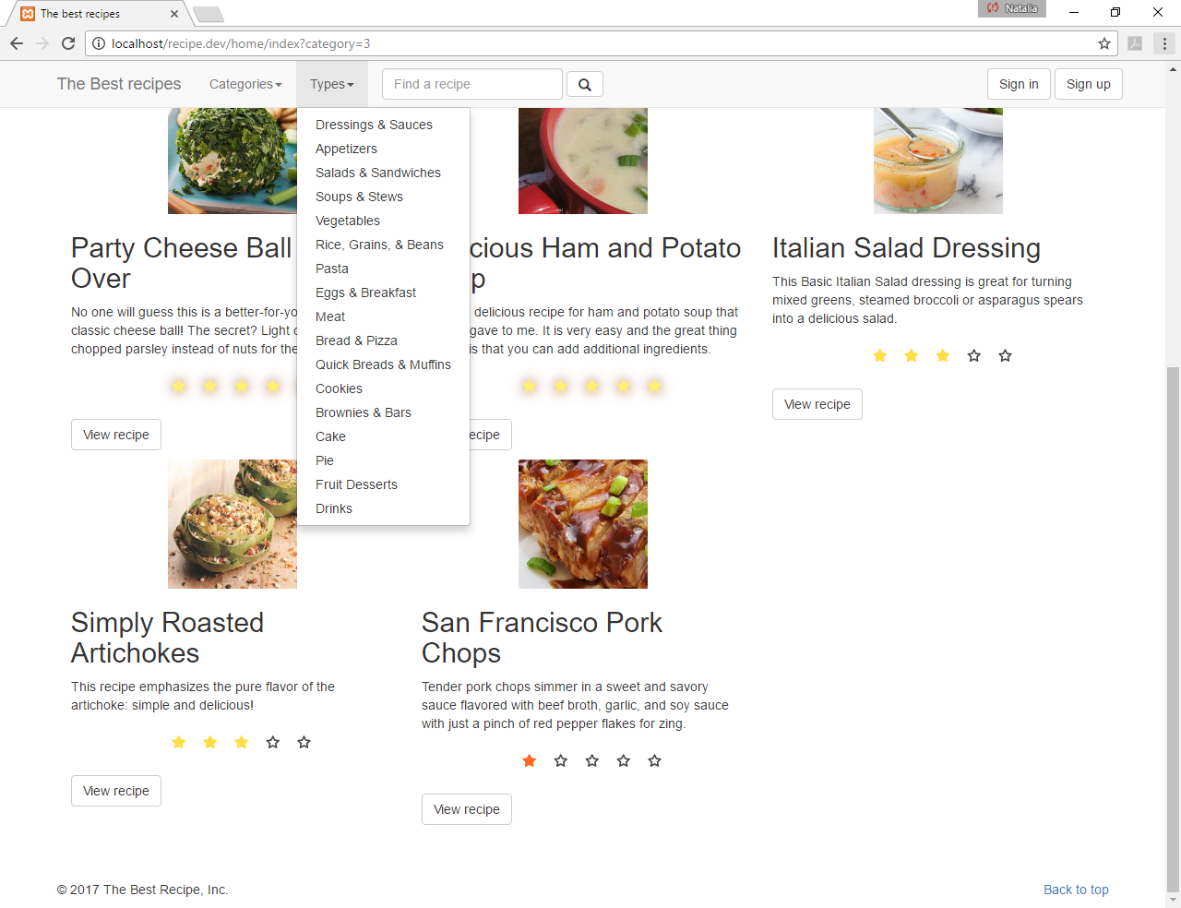

Result searching by type “Dressings&Sauces”

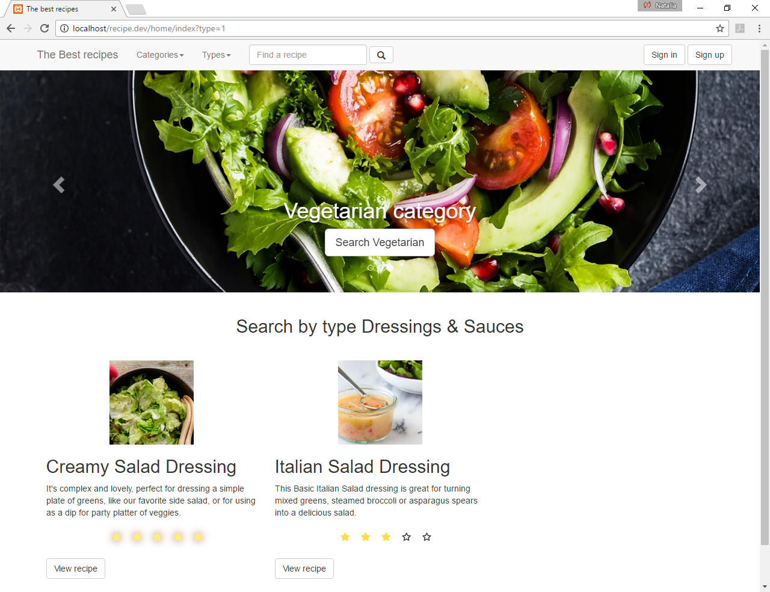

To find a recipe by word , enter a word and click find. The %word% will be searched in types, categories , recipe names or ingridients.

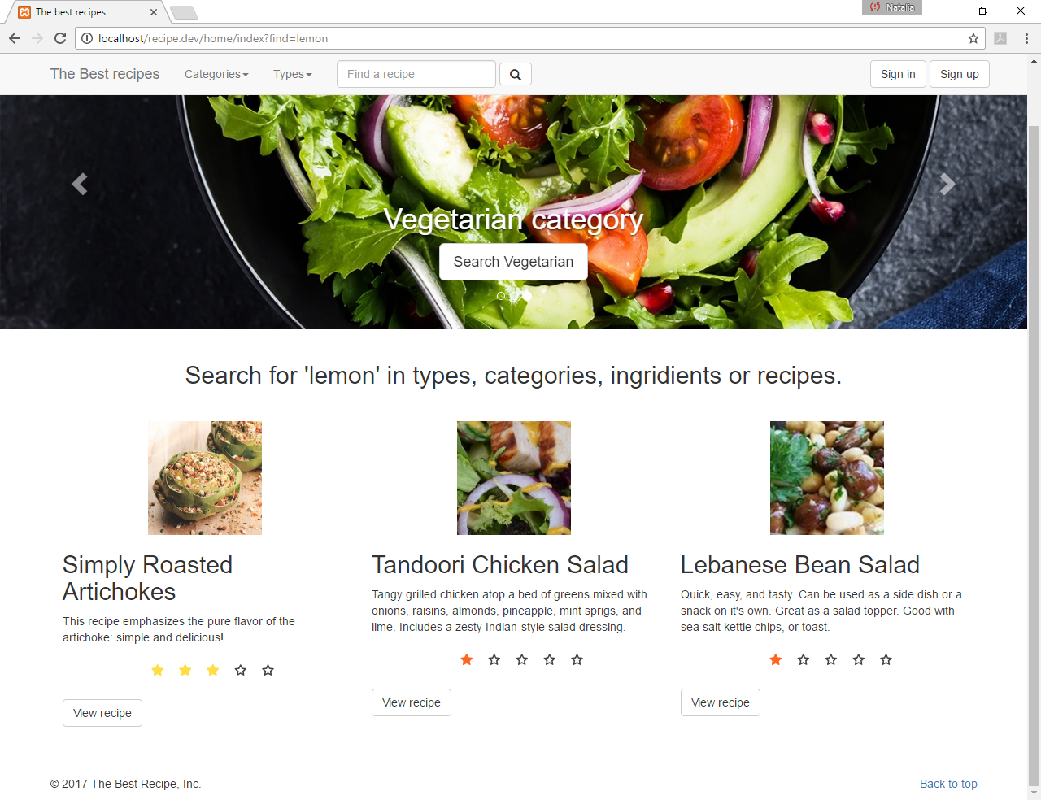

Click VIEW RECIPE to display more details

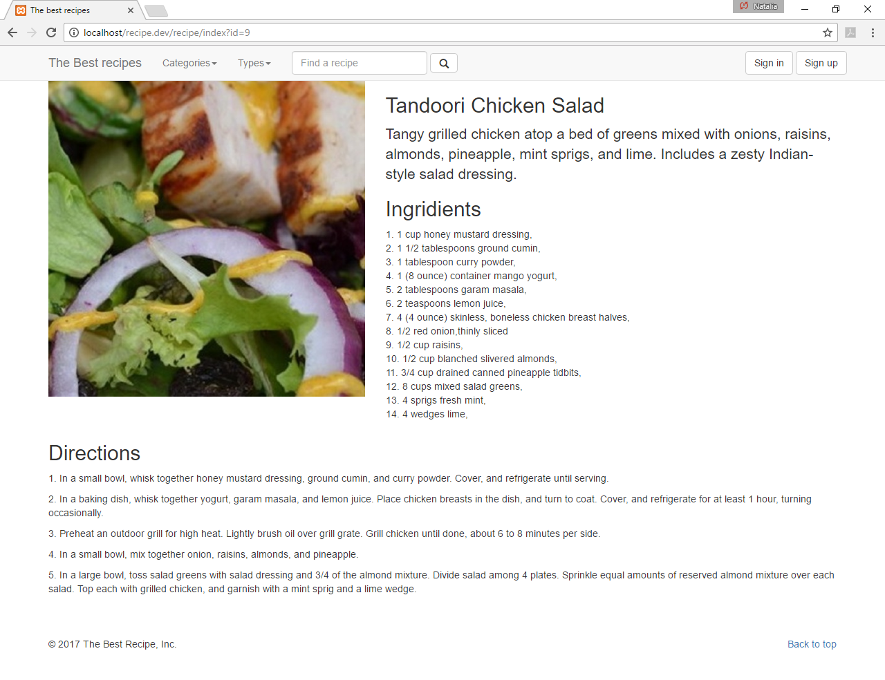

Sign In , Validation

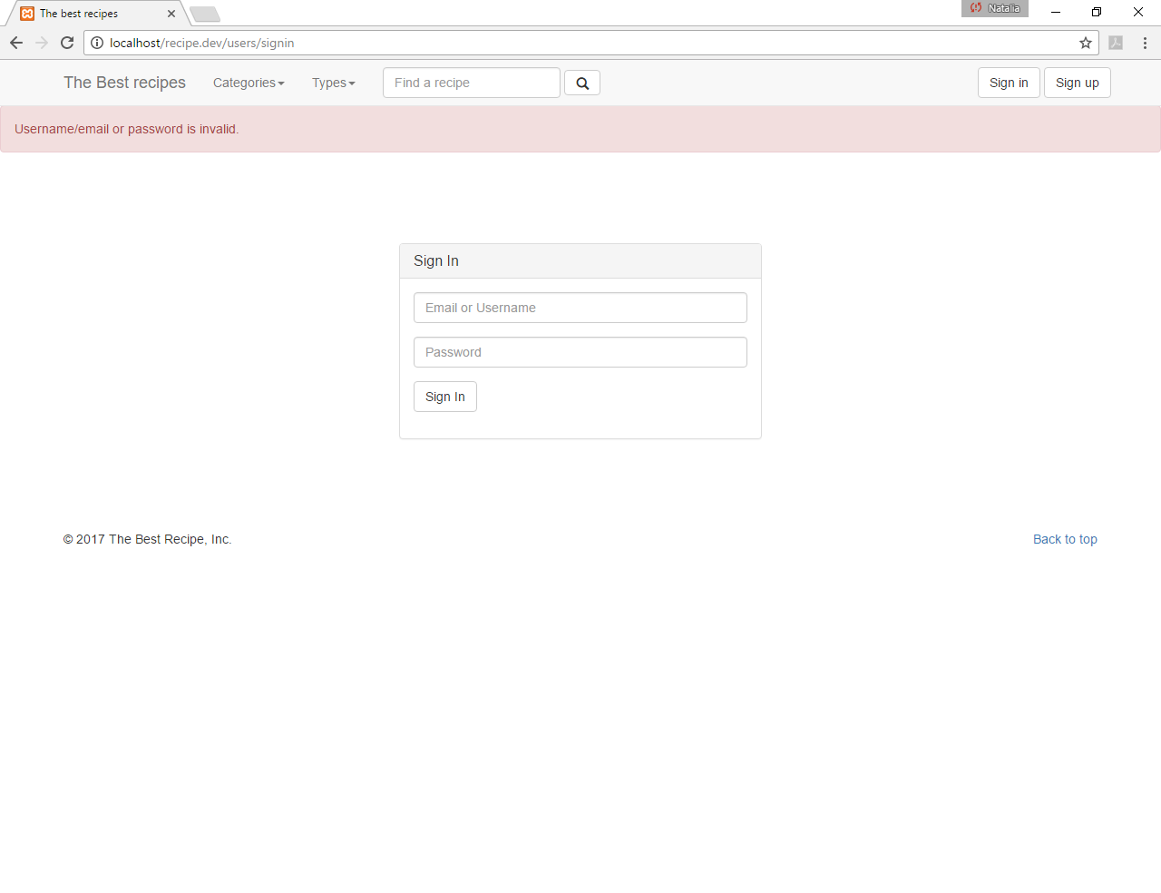

Sign Up , Validation

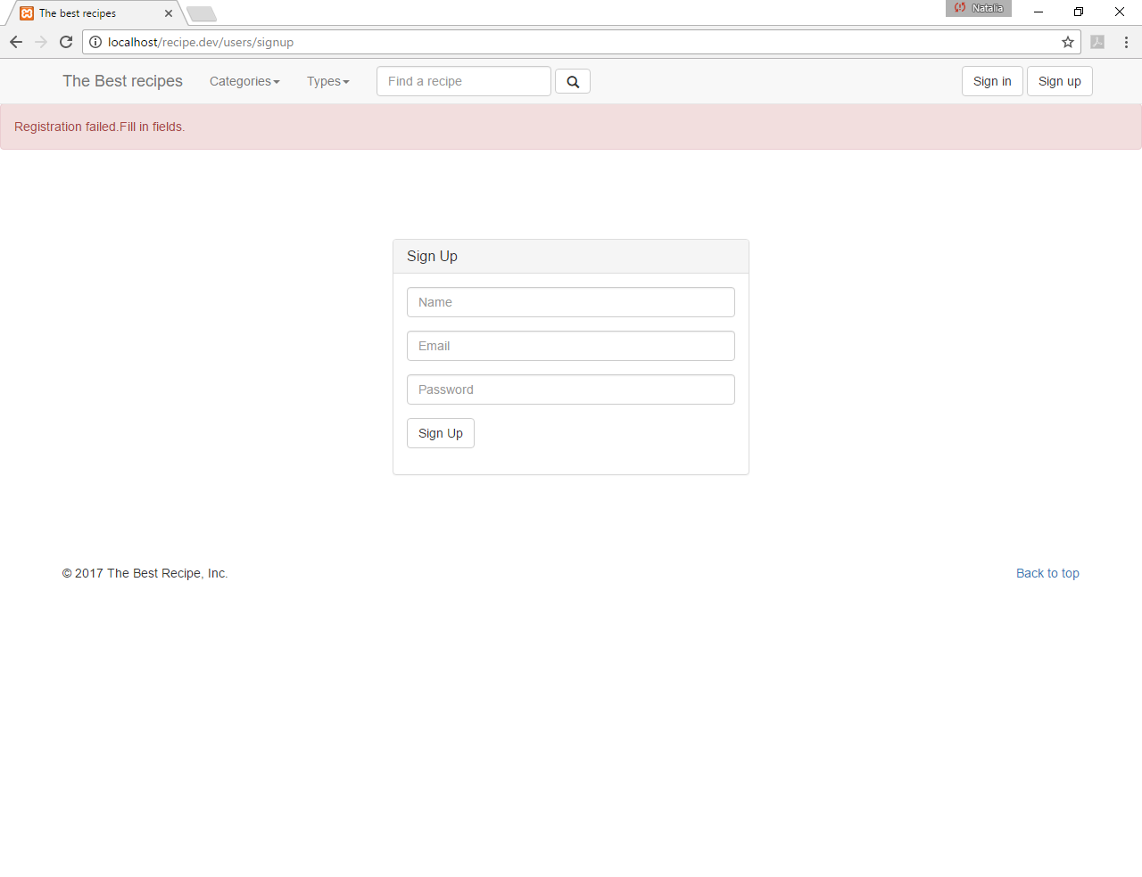

When user is logged in , it displays users info and favorite recipes

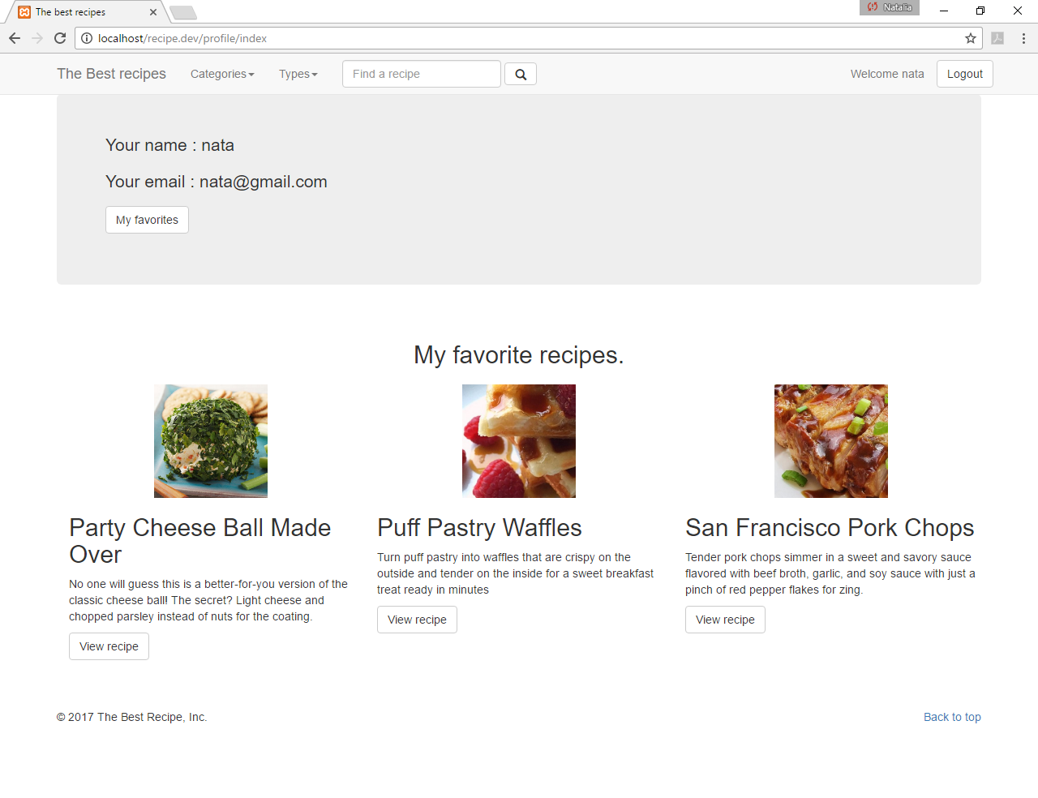

When user logged in , additional info – rating , add/delete from favorite recipe, display and leave a comment

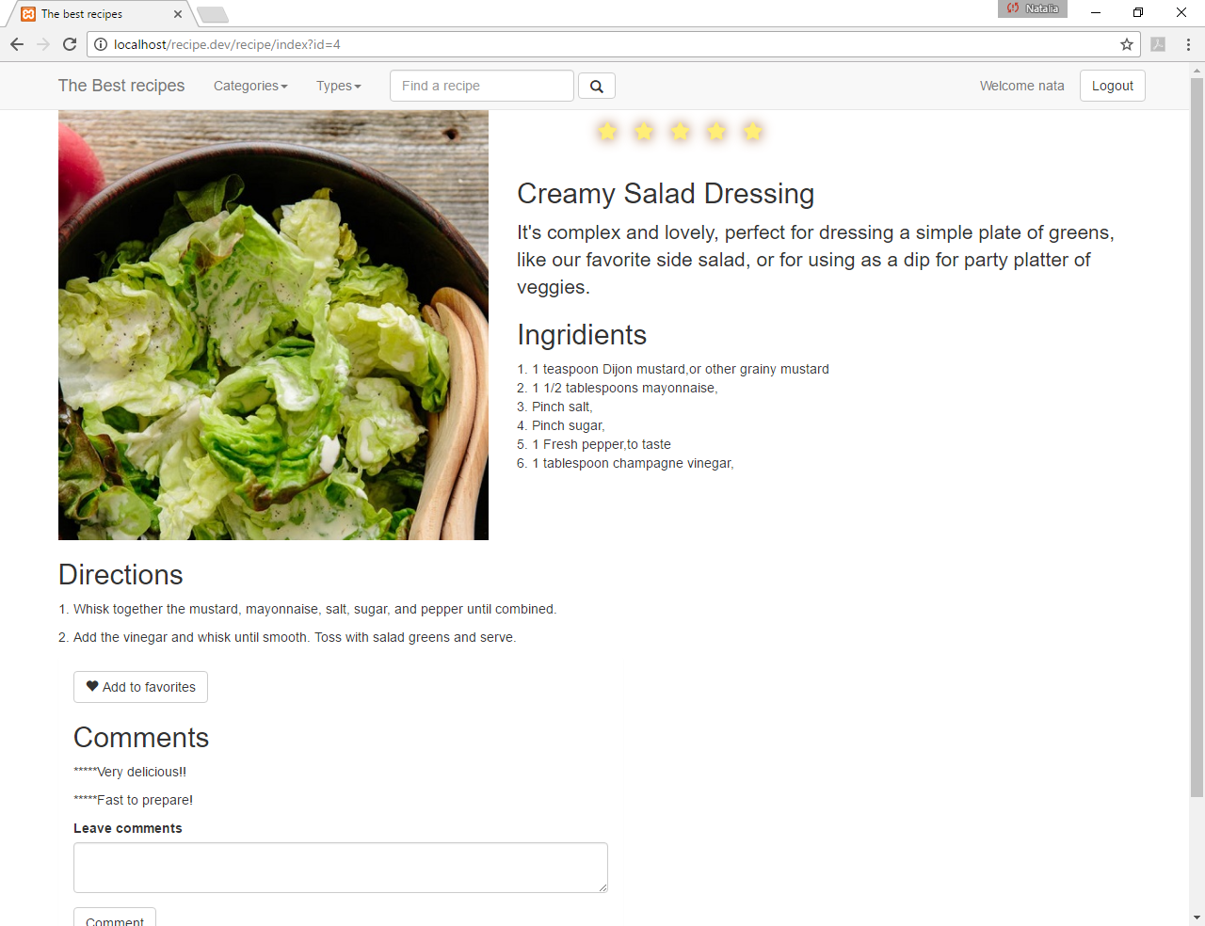

Click Add to favorites , to add recipe in a list of favorite

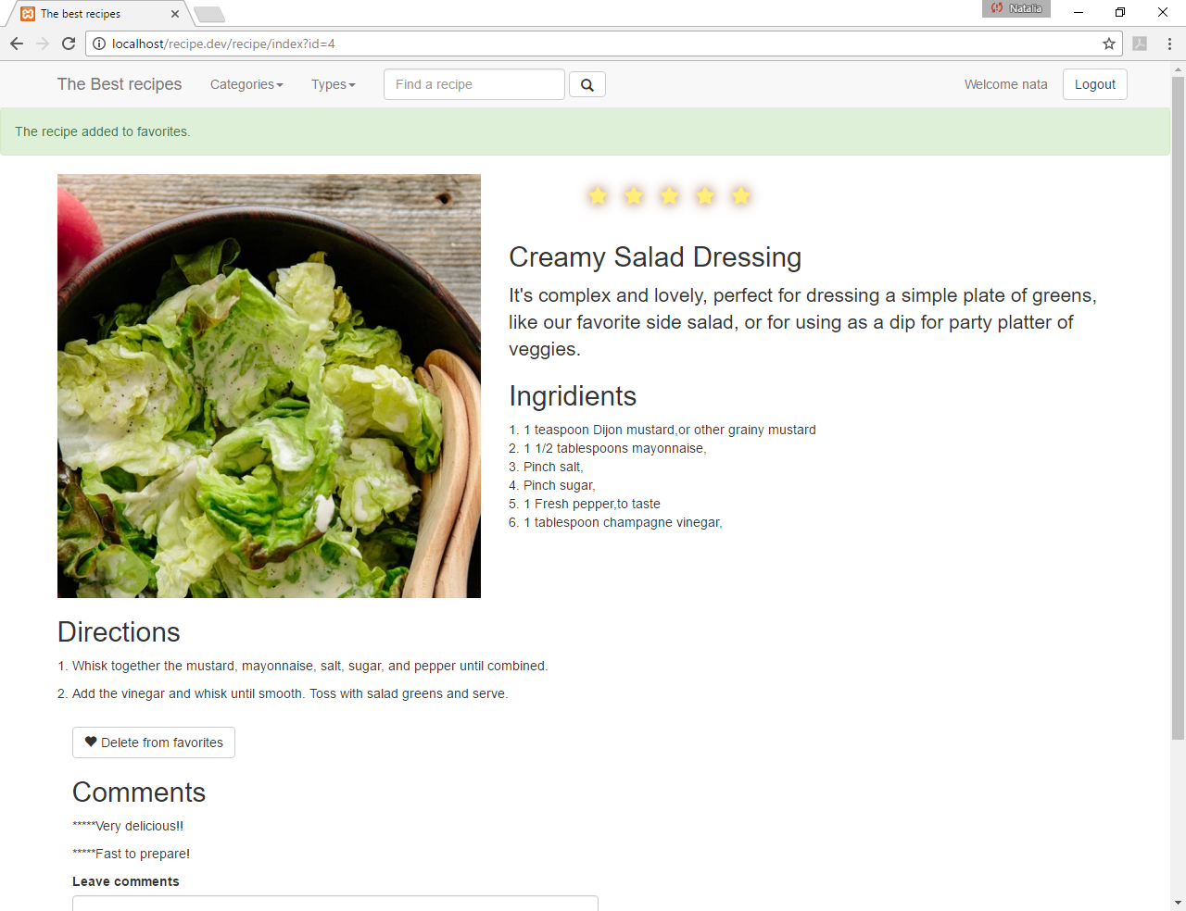

OR click Delete from favorites , to add recipe in a list of favorite

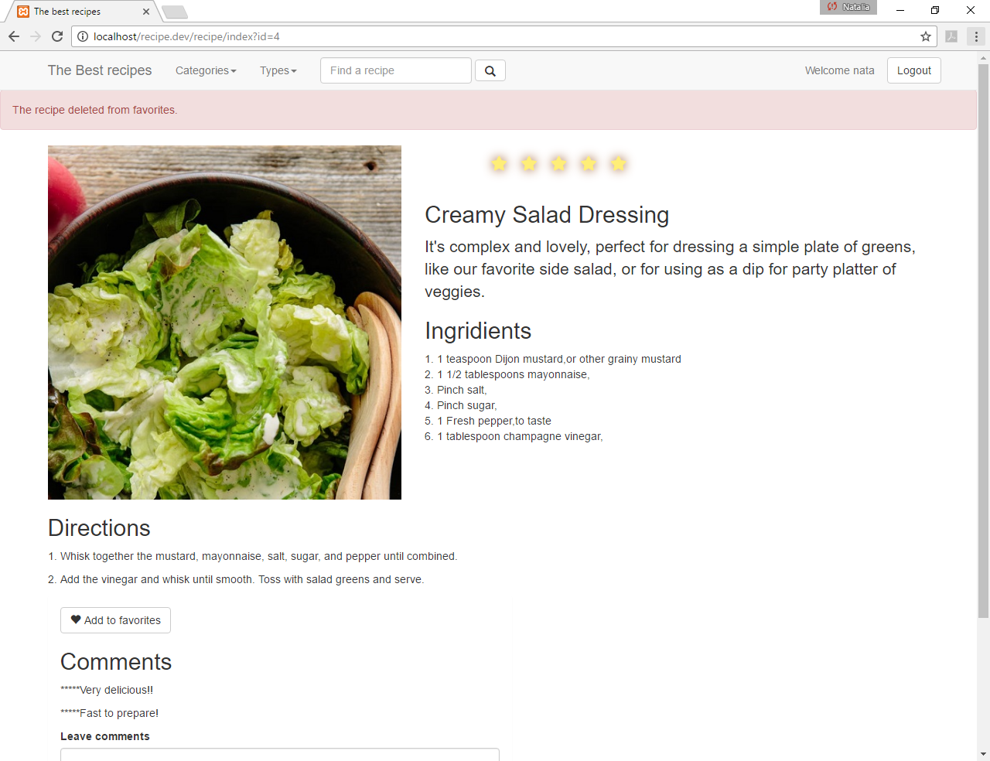

Enter a comment and click Comment

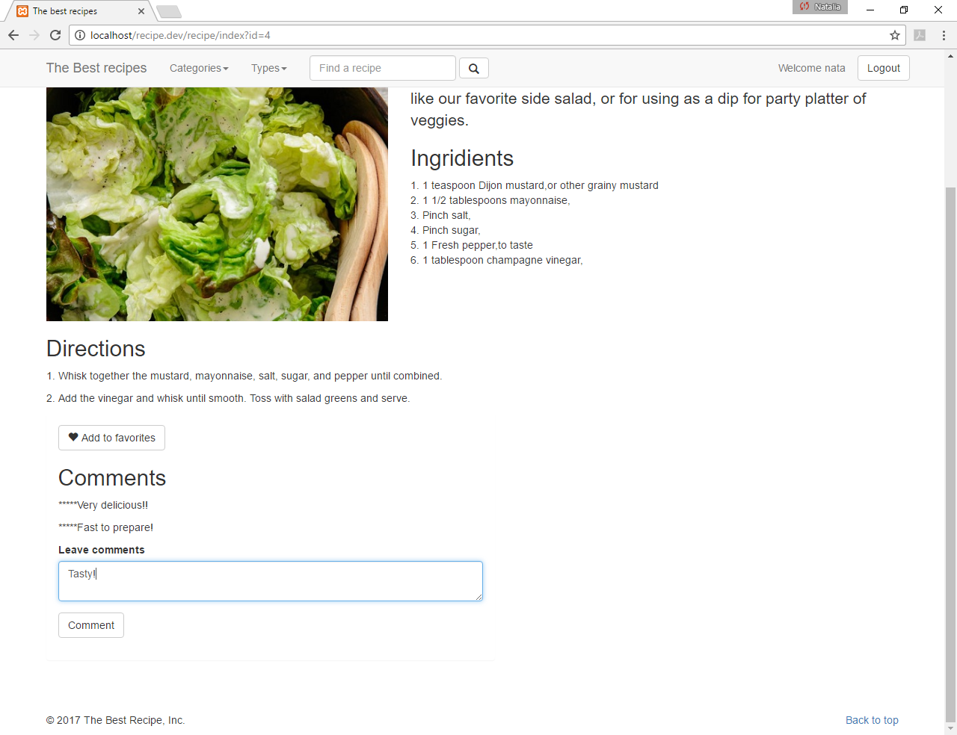

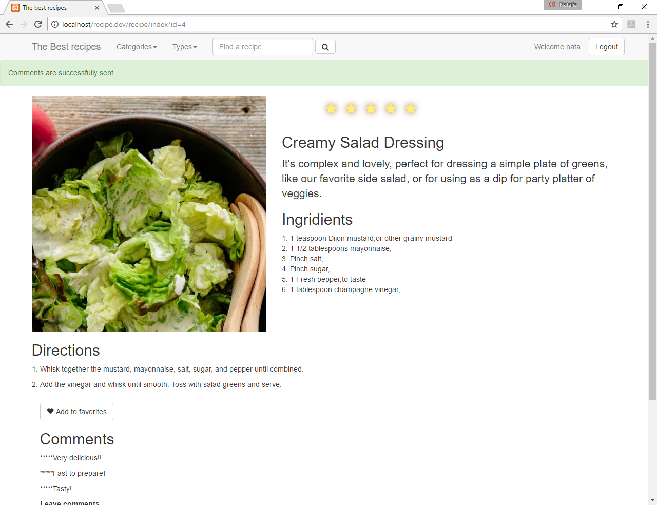

Click LogOut to exit from user account.